Bench Sales Recruiting Application — MVP Scope
Status: Draft for review · Version: 0.1 · Date: 2 June 2026
This document defines the scope of the MVP: what each component is responsible for, what it explicitly is not, and how the pieces come together end to end. It assumes the POC has validated the three risky bets (retrieval relevance, posting data quality, assisted-apply feasibility) and that we are now building the first real, usable version. Companion artifacts: the architecture-flow diagram, the level-1 data-flow diagram, and the retrieval funnel.

1. Overview
The application helps a bench sales recruiter market their assigned consultants ("candidates") to relevant job postings, with the heavy lifting — finding jobs, judging fit, tailoring resumes, drafting outreach — automated. The agent applies to a candidate's top matches unattended (auto-submit), while the recruiter stays in control of public outreach (sending email) and authorizes each candidate's apply session at login.
The core loop: a recruiter triggers a job pull from Dice; the system stores and ranks postings against each candidate; for the best matches it generates a tailored resume; the recruiter reviews and submits the application (assisted), and can send a cold email to the hiring contact with the candidate cc'd; every application is tracked to completion.
2. Personas & roles
- Bench sales recruiter — the end user. Manages a set of assigned candidates, triggers fetches and matching, reviews and submits applications, sends outreach, tracks status.
- Candidate — a consultant the recruiter represents. Not a user of the system in the MVP; represented as data (profile, resume, applications).
- Hiring contact — the recipient of cold outreach. External; not a user.
3. Goals and non-goals
Goals (MVP)
- A recruiter can go from "fetch jobs" to a ranked, per-candidate shortlist of fresh, relevant, not-yet-applied postings without manual searching.
- For top matches, the system produces a truthful tailored resume and a posting-specific cold-email draft.
- The recruiter can complete an application (assisted) and send outreach, and see every application's status in one place.
- The agent auto-submits applications across a candidate's top matches once the recruiter has started the session; public email send remains an explicit recruiter action.
Non-goals (MVP) — deliberately out of scope to keep v1 tight:
- Unattended supplemental-question handling. The agent pauses (HITL) for the recruiter to answer application questions it cannot truthfully answer on its own; everything else, including submit, is automated. Rationale: ToS and anti-bot risk is accepted and mitigated by sandboxing, session-login authorization, and rate limiting rather than a per-submit human gate.
- External ATS applications (Workday, Greenhouse, etc.). MVP targets Dice native "Easy Apply" only. Rationale: each ATS is a separate, much larger feasibility problem.
- Contact enrichment. Hiring-contact emails come from the posting or are entered by the recruiter — no third-party enrichment service yet.
- Resume parsing / auto-ingest of candidate profiles. Profiles are entered as structured data in v1.
- Scheduling and autonomous runs. Everything is recruiter-triggered; no cron-driven pipelines.
- Multi-channel outreach, analytics dashboards, candidate-facing portal. Later.
4. Scope at a glance
Phase | Focus | Status
POC | De-risk retrieval relevance, posting quality, assisted-apply feasibility | Assumed complete
MVP (this doc) | Usable end-to-end loop for a recruiter: fetch → match → tailor → assisted apply → email → track | In scope
Later | External ATS apply, enrichment, automation/scheduling, resume parsing, dedicated vector DB, analytics | Out of scope
5. Key decisions and assumptions
These are settled unless flagged. Open items are called out again in §13.
- Automated apply, agent submits. The agent fills a Dice Easy Apply form and submits it unattended, pausing (HITL) only for supplemental questions it cannot truthfully answer and to start the candidate session at login. CAPTCHA / anti-bot encounters are recorded as blockers, never bypassed. (Open: accepted ToS/account risk of auto-submit — see §13.)
- Dice Easy Apply only for the apply path; external ATS deferred. Ingestion still records apply_type so coverage (Easy Apply vs external) is measurable.
- pgvector inside Postgres, not a separate vector index. Freshness, applied-exclusion, and similarity compose into one query, which removes a sync/consistency problem. A dedicated vector DB is a scale-time swap.
- Embeddings prefilter then LLM re-rank. Cheap vector shortlist first, LLM fitment scoring only on the top-K.
- Truthful generation. Resume tailoring and email drafting reframe and emphasize the candidate's real experience only — never invent skills, employers, dates, or accomplishments.
- Cold email is sent via the recruiter's connected Gmail (OAuth), from the recruiter, candidate cc'd. (Open: confirm send is in MVP vs. draft-only.)
- Multi-recruiter tenancy. Candidates are assigned to recruiters; data is scoped per recruiter and the API enforces it. (Open: confirm vs. single-recruiter v1.)
6. System architecture
Five layers (see the architecture-flow diagram for the runtime picture):
- Recruiter portal — web frontend: candidate list, job/match views, resume review, application tracker, email composer.
- Backend API — authentication, tenancy enforcement, and orchestration. Serves the portal's reads (including tracking) directly from Postgres; enqueues long-running work.
- Task queue + worker pool — runs the pipeline stages asynchronously (fetch, score, tailor, apply-prep, email), since each involves slow external calls.
- Data layer — Postgres (with pgvector) as the system of record and similarity store; object storage for generated .docx resumes.
- External services — Dice (job search + apply surface), Anthropic API (scoring, tailoring, drafting), Gmail (outbound email).
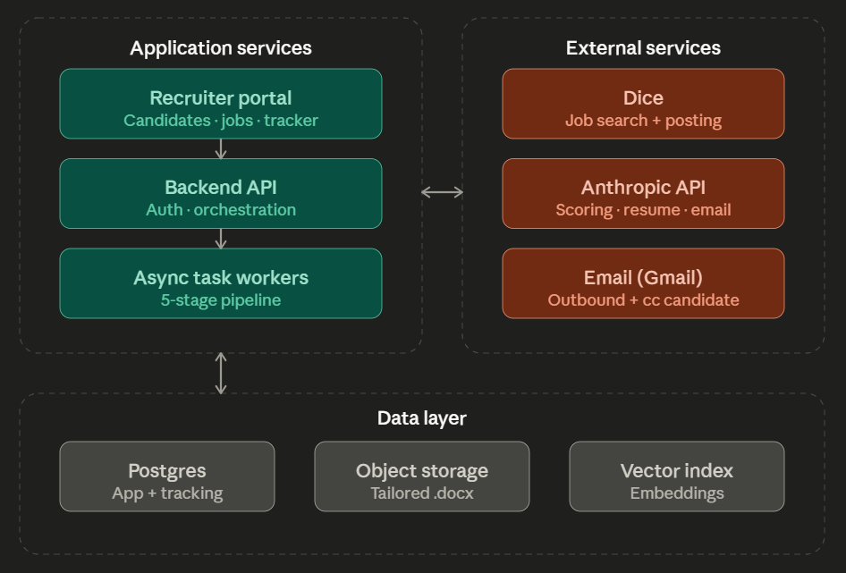
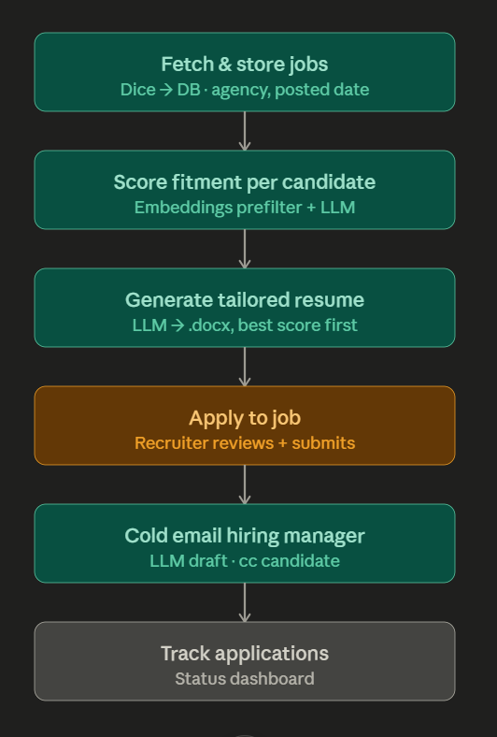
7. Data model
Core entities and where they live. (* = pgvector column.)
Entity | Purpose | Key fields | Store
Recruiter | Tenant / owner | id, name, gmail_oauth | Postgres
Candidate | Represented consultant | id, recruiter_id, titles, skills, locations, work_auth, summary, profile_vector* | Postgres
JobPosting | A fetched posting | id, source, external_id, title, company, agency, location, remote, posted_date, first_seen, last_seen, description, embed_text, embedding*, apply_type, contact_email, content_hash, url | Postgres
FitmentScore | LLM judgement of a pair | candidate_id, job_id, score, rationale, missing_requirements | Postgres
TailoredResume | Generated resume | candidate_id, job_id, docx_path, created_at | object storage + Postgres pointer
Contact | Hiring contact for a posting | job_id, name, email, source | Postgres
Outreach | Cold email record | candidate_id, job_id, to, cc, subject, body, sent_at | Postgres
Application | Tracked application | candidate_id, job_id, status, resume_id, applied_at, submitted_by | Postgres
Three timestamps on a posting are intentional: posted_date (from Dice — freshness filtering), first_seen / last_seen (our ingestion — re-fetch and aging). content_hash supports dedup and cross-agency repost detection.
8. Component scope
Each component below lists its responsibility, its input→output boundary, key behavior, dependencies, what's out of scope for the MVP, and a "done when" check.
8.1 Recruiter portal (frontend)
- Responsibility: the recruiter's entire surface — manage candidates, trigger fetch/matching, review matches and resumes, compose/approve email, submit applications, track status.
- In → Out: recruiter actions → API calls; renders API/Postgres reads.
- Key behavior: triggers are explicit buttons; the apply and send actions are framed as recruiter-performed, not system-performed.
- Depends on: Backend API.
- Out of scope: candidate self-service, mobile-native, real-time collaboration.
- Done when: a recruiter can complete the full loop for one candidate from the UI.
8.2 Backend API (auth, tenancy, orchestration)
- Responsibility: authenticate the recruiter, enforce that they only see their own candidates/data, orchestrate pipeline triggers, serve reads.
- In → Out: authenticated requests → enqueued jobs and JSON reads.
- Key behavior: tenancy is enforced server-side on every query; long work is enqueued, not run inline; tracking reads hit Postgres directly for freshness.
- Depends on: Postgres, task queue.
- Out of scope: SSO, role hierarchies beyond "recruiter," public API.
- Done when: a recruiter cannot access another recruiter's candidates or postings, and triggers reliably enqueue work.
8.3 Task queue + worker runtime
- Responsibility: run pipeline stages asynchronously and reliably.
- In → Out: enqueued job (e.g. "fetch for candidate X") → completed work with status.
- Key behavior: retries on transient external failures; one stage's output is persisted before the next reads it.
- Depends on: queue/broker, Postgres, object storage.
- Out of scope: distributed scaling, priority scheduling, cron.
- Done when: a triggered fetch+score run completes and surfaces results without blocking the request.
8.4 Candidate intake
- Responsibility: load a candidate profile into a typed record and compute its embedding.
- In → Out: structured profile → Candidate row + profile_vector.
- Key behavior: re-embeds when the profile changes; the vector is reused at query time (retrieval embeds nothing live).
- Depends on: Anthropic/embedding backend, Postgres.
- Out of scope: resume-file parsing, profile enrichment.
- Done when: a saved profile produces a stored vector and appears assignable to a recruiter.
8.5 Job ingestion — fetch & normalize
- Responsibility: pull postings from Dice and turn them into clean, deduped, embedded records.
- In → Out: candidate-derived Dice query → JobPosting rows with embeddings and metadata.
- Key behavior: normalize emits canonical fields, a distilled embed_text (title + must-have skills + responsibilities, boilerplate stripped), and a content_hash; classifies apply_type; dedups on external_id and flags reposts via content_hash; upserts update last_seen and posted_date; embeds embed_text once (re-embed only on hash change).
- Depends on: Dice, embedding backend, Postgres.
- Out of scope: scraping external ATS detail pages, scheduled fetches.
- Done when: a fetch yields normalized, deduped, embedded postings with all three timestamps populated.
8.6 Retrieval & shortlisting
- Responsibility: for a candidate, return the freshest, most relevant, not-yet-applied postings.
- In → Out: candidate vector + filters → top-K postings.
- Key behavior: one pgvector query combining a prefilter — (1) posted_date >= now - window, (2) exclude job_ids already applied for this candidate, (3) in-scope only (apply_type = easy_apply, plus VISA/work-auth, years-of-experience, and location compatibility) — with ORDER BY embedding distance, capped at K. Filtering and ranking happen together, so stale/applied postings are never ranked.
- Depends on: Postgres + pgvector.
- Out of scope: cross-candidate recommendation, recency-weighted scoring (freshness is a hard window, not a score blend).
- Done when: results exclude applied and out-of-window postings and rank plausibly by fit.
8.7 Fitment scoring (LLM re-rank)
- Responsibility: judge each shortlisted pair and produce a fitment_score + rationale.
- In → Out: (candidate, posting) → score 0–100, rationale, missing requirements.
- Key behavior: runs only on the top-K from retrieval; kept separate from retrieval so a bad result is attributable; final shortlist sorts by score.
- Depends on: Anthropic API.
- Out of scope: fine-tuned scoring models, batch scoring of the whole pool.
- Done when: obviously-good pairs outscore obviously-bad ones and rationales are specific.
8.8 Resume tailoring
- Responsibility: reframe the candidate's real experience toward a posting and render a .docx.
- In → Out: (candidate, posting) → tailored .docx in object storage.
- Key behavior: generates best-fitment-first; never fabricates experience the profile lacks; renders to a clean, openable Word doc.
- Depends on: Anthropic API, object storage.
- Out of scope: multiple templates/branding, PDF export.
- Done when: a generated resume opens correctly and contains only truthful, reframed content.
8.9 Contact resolution
- Responsibility: find a hiring-contact email for a posting, or report none.
- In → Out: posting → Contact (email or null + source).
- Key behavior: uses the posting's contact if present, else null for the recruiter to fill manually.
- Depends on: Postgres.
- Out of scope: third-party enrichment.
- Done when: the system reports a hit-rate and lets the recruiter supply a missing email.
8.10 Cold email (draft + send)
- Responsibility: draft a posting-specific cold email and send it from the recruiter's Gmail.
- In → Out: (candidate, posting, contact) → EmailDraft → sent Outreach record.
- Key behavior: LLM drafts subject + body (truthful, specific to the posting); the recruiter reviews; sending goes through the recruiter's connected Gmail (OAuth), from the recruiter, candidate cc'd; an Outreach row is logged on send.
- Depends on: Anthropic API, Gmail, Postgres.
- Out of scope: sequences/follow-ups, templates library, deliverability tooling.
- Done when: a recruiter can review a draft and send it, and the send is logged. (Gated on the draft-vs-send open question.)
8.11 Assisted apply
- Responsibility: drive a sandboxed browser to fill and submit a Dice Easy Apply form for each of a candidate's top matches, pausing only for supplemental questions and the candidate-session login.
- In → Out: (candidate session, postings, resumes) → forms filled and submitted unattended → Application records (with any supplemental-question pauses resolved by the recruiter).
- Key behavior: a visible browser session, logged in under the candidate's Dice credentials (entered live by the recruiter at session start — a human-in-the-loop pause that begins the candidate's apply run; credentials are never stored); the session may span all of that candidate's top matches; for each posting the agent fills fields and attaches the resume, then hard-stops before submit; submit is never automated; CAPTCHA/anti-bot are recorded as blockers; records fields filled vs. corrected.
- Depends on: browser automation (Playwright / Claude in Chrome), object storage, Postgres.
- Out of scope: external ATS, headless auto-submit, bulk/unattended auto-submit (a candidate session may span multiple postings, but each submit stays a per-application human action).
- Done when: the agent fills and submits Easy Apply postings across a candidate's session unattended, escalates supplemental questions correctly, and submitted_by reflects the agent.
8.12 Application tracking
- Responsibility: show every application's status per candidate.
- In → Out: Application + Outreach records → status views.
- Key behavior: reads Postgres live via the API; statuses cover at least drafted/applied/emailed/closed.
- Depends on: Postgres, API.
- Out of scope: automated status sync from Dice/employers, analytics.
- Done when: every action in the loop produces a visible, correct status entry.
8.13 Cross-cutting: config, eval & quality
- Config/secrets: model names, embedding backend, freshness window, DB path, and credentials live in environment/secrets, never in code. Gmail/Dice auth via OAuth/stored credentials.
- Eval harness: relevance measured with precision@k / nDCG against hand-labeled pairs; data quality audited for completeness, dedup rate, freshness, and Easy-Apply share; assisted-apply measured by fill accuracy / correction rate / blockers. These are the same gates the POC used and remain the regression signal.
9. How it comes together (end-to-end)
- The recruiter selects a candidate and triggers a fetch. The API enqueues a job; a worker queries Dice, normalizes, dedups, embeds, and upserts postings.
- The recruiter triggers matching. Retrieval runs the pgvector funnel (fresh, unapplied, in-scope, ranked by similarity); the LLM re-ranks the top-K into a scored shortlist.
- For top matches, the recruiter generates tailored resumes; each renders to a .docx in object storage.
- The recruiter starts an apply session for the candidate, logging in under the candidate's Dice credentials at the human-in-the-loop pause. For each top match, the assisted-apply driver fills the Easy Apply form and stops; the recruiter submits; an Application is logged.
- Optionally, the recruiter resolves the hiring contact, reviews the LLM email draft, and sends it via Gmail (candidate cc'd); an Outreach record is logged.
- The tracker reflects each application's status, read live from Postgres.
10. Cross-cutting concerns
- Guardrails: no CAPTCHA/anti-bot bypass in apply; no fabrication in resume/email; the agent never answers supplemental questions it cannot truthfully answer (it escalates to the recruiter); test account during apply development.
- ToS & account safety: unattended auto-submit against Dice carries elevated account/ToS risk, accepted for v1. With the human-submit gate removed, the mitigations are a sandboxed visible session per candidate, recruiter-authorized session login under the candidate's credentials, rate limiting / human-like pacing, and the supplemental-question pause; CAPTCHA/anti-bot is never bypassed. Account viability is treated as an explicit signal, and the accepted risk is flagged in §13.
- Security & privacy: per-recruiter tenancy enforced server-side; secrets in environment; candidate PII confined to the recruiter's tenant; OAuth tokens stored securely.
- Candidate-session login: applying through a candidate's Dice profile requires a session under that candidate's credentials, not the recruiter's. The recruiter enters the candidate's credentials live at session start; the system never stores them. A human-in-the-loop pause precedes each candidate's apply run so the recruiter authenticates as the candidate before any top-match applications begin. This gate is distinct from — and earlier than — the per-application pre-submit stop in §8.11.
- Reliability: worker retries on transient external failures; each stage persists before the next consumes it.
11. Requirements priority
- P0 (cannot ship without): candidate intake; fetch & normalize; retrieval funnel; fitment scoring; resume tailoring; assisted apply (human submit); application tracking; auth + tenancy.
- P1 (fast follow): cold email send; contact resolution; quality/eval dashboards in-app.
- P2 (design-for, don't build): external ATS apply; enrichment; scheduled/automated runs; dedicated vector DB; resume parsing.
12. Success criteria (MVP is done when)
- A recruiter completes the full loop for a real candidate end to end without leaving the app or hand-searching Dice.
- Retrieval reliably surfaces fresh, in-scope, not-yet-applied postings, and relevance clears the precision@k bar set in the POC.
- Generated resumes are truthful and open cleanly; the assisted-apply driver reaches review-ready on Easy Apply postings with a low correction rate.
- Every application and outreach is tracked accurately; the agent auto-submits a candidate's top matches after the recruiter starts the session, and no email send happens without the recruiter.
13. Open questions
- Tenancy (stakeholder): confirm multi-recruiter for v1, or single-recruiter dogfood? Changes the auth layer and tenant keys. Blocking for the data model.
- Email (stakeholder): is Gmail send in the MVP, or draft-only with manual send? Changes whether Gmail/OAuth is built now. Blocking for §8.10.
- Freshness window (config): default length for the posted_date filter (start 21–30 days?). Non-blocking — tunable.
- Re-apply policy (product): never re-surface an applied posting, or re-surface after a rejection? Non-blocking — default to never for v1.
- Auto-submit ToS risk (stakeholder / legal): unattended auto-submit removes the human-submit gate that was the primary ToS/anti-bot mitigation. Confirm acceptance of the elevated account-ban / ToS risk, and the mitigation set (sandboxed session, recruiter-authorized login, rate limiting, supplemental-question pause). Default for v1: accepted. Blocking if legal has not signed off.
- Candidate credential handling (stakeholder / security): confirm live entry at session start with nothing stored, vs. securely storing candidate Dice credentials for reuse. Default to live-entry/never-stored for v1; touches §8.11 and §10. Non-blocking, but revisit if recruiters need to resume sessions.
- Dedup aggressiveness (engineering): exclude only exact job_id, or also content_hash near-duplicates, when filtering applied postings? Non-blocking.
14. Out of scope / future
External ATS applications; contact enrichment; autonomous scheduling; resume parsing and auto-ingest; dedicated vector database; multi-channel and sequenced outreach; in-app analytics; a candidate-facing experience.
15. Glossary
- Bench / bench sales: consultants between projects whom the recruiter markets to open roles.
- Easy Apply: Dice's native in-platform application (vs. an external ATS redirect).
- Fitment score: the LLM's 0–100 judgement of how well a candidate matches a posting.
- Prefilter: the relational predicates (freshness, applied-exclusion, scope) applied alongside vector similarity at retrieval time.
- Automated apply: the agent fills and submits the application unattended, pausing only for supplemental questions and the candidate-session login.

